Math Worksheet #1.1
- (1-6ex4) 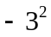
- (1-6ex4) 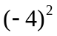
- (4-3) ___% of 5 = 1
- (4-3) 5% of 25 = _____
- (4-3) ___% of 4 = 1
- (4-3) 15% of 7 = _____
- (4-3) ___% of 2 = 1

- Convert to standard form: 1.54E-03
- Convert to standard form: 3.76E+03
- Convert to scientific notation: 1,314,000
- Convert to scientific notation: .012965
- Simplify the following expression given a = 6 and b = 4: 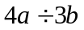
- (4-4) What is the percent of change from 8 to 4?
- (4-4) What is the percent of change from 4 to 8?
- (4-4) What is the percent of change from 4 to 3?
- (4-4) What is the percent of change from 10 to 8?
- (4-4) What is the percent of change from 5 to 10?
- (4-6) P(2 then even) for two rolls of a die.
- (4-6) P(less than 4 then odd) for two rolls of a die.
- (4-1ex2) A tree casts a 55-ft shadow. A boy standing nearby casts a 25-ft shadow. His height is 5 ft. How tall is the tree?
- (4-1ex6) Solve 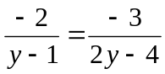
- (5-4ex3) Suppose you buy a lawn mower for $1200. You charge $25 per grass-cutting. Write an equation to describe your profit.
- 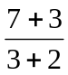
- 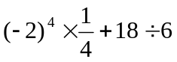
Math Worksheet #1.2
- Convert to decimal: 
- 70% of ____ = 70
- State the midpoint formula.
- (3-6) Find the solutions for 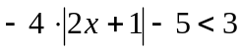
- (7-3ex1) Solve the following system of equations: 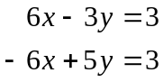
- (8-1ex2) Simplify: 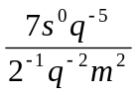
- (8-3ex3) Simplify: 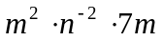
- (8-4ex4) Simplify: 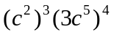
- (8-5ex4) 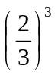
- (9-2ex3) Factor: 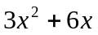
- (9-7ex4) Factor: 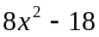
- (9) Factor: 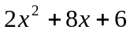
- (9-8) Factor: 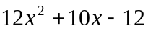
- (11-2ex1) What is the length of the hypotenuse of a right triangle with legs of length 3cm and 4cm?
- (10-4ex2) Solve: 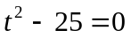
Math Worksheet #1.3
- Convert to decimal: 
- What % of 300 is 60?
- Solve and give the answer in decimal form: 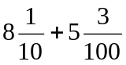
- State the formula for the slope of a line given two points.
- (3-6) Find the solutions for 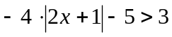
- (7-2ex1) Solve the following system of equations: 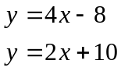
- (8-1ex2) Simplify: 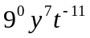
- (8-3ex3) Simplify: 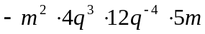
- (8-4ex4) Simplify: 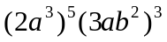
- (8-5ex4) 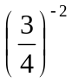
- (9-3ex3) Simplify:
- (9-2ex3) Factor: 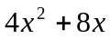
- (9-7ex4) Factor: 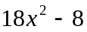
- (9) Factor: 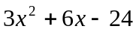
- (9-8) Factor: 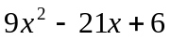
Math Worksheet #1.4
- Solve: 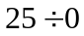
- Convert to decimal: 
- 12.5% of ______ = 10
- Solve and give the answer in decimal form: 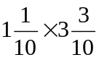
- (6-2) Give the slope-intercept form of a line, and describe each variable.
- (3-6) Find the solutions for 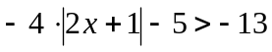
- (7-3ex3) Solve the following system of equations: 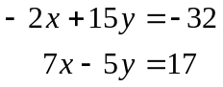
- (8-1ex3) Evaluate the following for 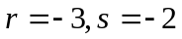: 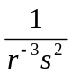
- (8-3ex3) Simplify: 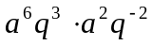
- (8-4ex4) Simplify: 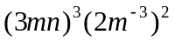
- (9-2ex3) Factor: 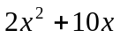
- (9-7ex4) Factor: 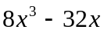
- (9) Factor: 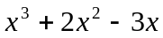
- (9-8) Factor: 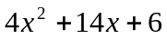
- (10-4ex2) Solve: 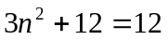
Math Worksheet #1.5
- Convert to decimal:
- 250% of _____ = 125
- (???) Give the equation for the relationship between rate, time, and distance.
- (7-2ex2) Solve the following system of equations: 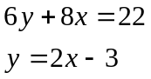
- (3-6) Find the solutions for 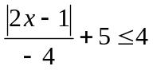
- (8-1ex3) Evaluate the following for : 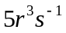
- (8-3ex3) Simplify: 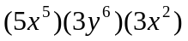
- (8-4ex4) Simplify: 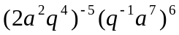
- (8-5ex4) 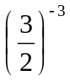
- (9-2ex3) Factor: 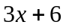
- (9-7ex4) Factor: 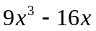
- (9) Factor: 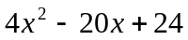
- (9-8) Factor: 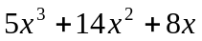
- (10-5ex3) Solve: 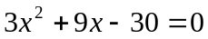
Math Worksheet #1.6
- Solve: 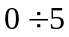
- Convert to decimal: 
- 50% of _____ = 79
- (10-7) State the quadratic formula.
- (7-3ex5) Solve the following system of equations: 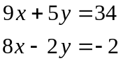
- (3-6) Find the solutions for 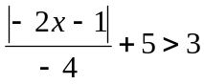
- (8-1ex3) Evaluate the following for : 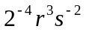
- (8-3ex3) Simplify: 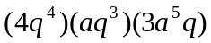
- (8-4ex4) Simplify: 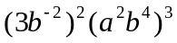
- (9-3ex3) Simplify:
- (9-2ex3) Factor: 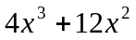
- (9-7ex4) Factor: 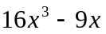
- (9-8) Factor: 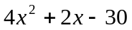
- (10-4ex2) Solve: 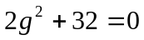
Math Worksheet #1.7
  - 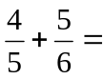
  - 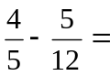
  - 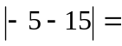
  - 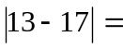
  - 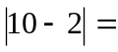
  - 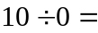
  - 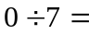
  - 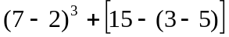
  - 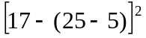
  - 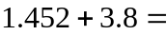
  - 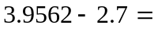
  - What are the prime factors of 63?
  - What are the prime factors of 60?
  - A rectangle has side lengths 10 and 4. What is its perimeter?
  - A trapezoid has side lengths 10, 8, 5, and 5. What is its perimeter?
  - A regular hexagon has side length 7. What is its perimeter?
  - Compute the mean, median, and mode of the following dataset: 5, 4, 7, 4
  - Convert to algebra. Alice has 5 more coins than Bob. Together they both have 15 coins.

